EMAX-RAP-Day26-1- 12.05.2026

Prechecks in RAP
Pre checks are similar to validation, what comes to the when compare with the validation.
if your recall the concept of the validation, when the validation will trigger? Validation trigger on save phase. but prechecks are not like that. but functionality of prechecks and validations are same for validate the data but triggering condition is different.
prechecks are will work - on assigning the value itself this validation will trigger.
Ex: Whenever i am going to book my journey, lets say i have the 5 days trips - if i select the start date from today(12.05.2026) to end date(!7.05.2026), can i able to select the 17.05.2026 to 12.05.2026? - it is not possible, start date should not be greater than end date. what i need to do by selecting the date itself if start date is the greater than end date, i have to trigger the validation of the selecting the date itself not on save. --> it is called as prechecks..
on changing the value itself, before saving the value - we need to trigger the validation.
Pre-checks validation only possible in Odata-V4., in V2- it is triggered on the save phase. n v2 even though precheck implemented - there is no usage..
Pre- checks can implement in all CRUD operations.--> pre checks implement in Create( ) update( ) delete( ) behavior implementation.
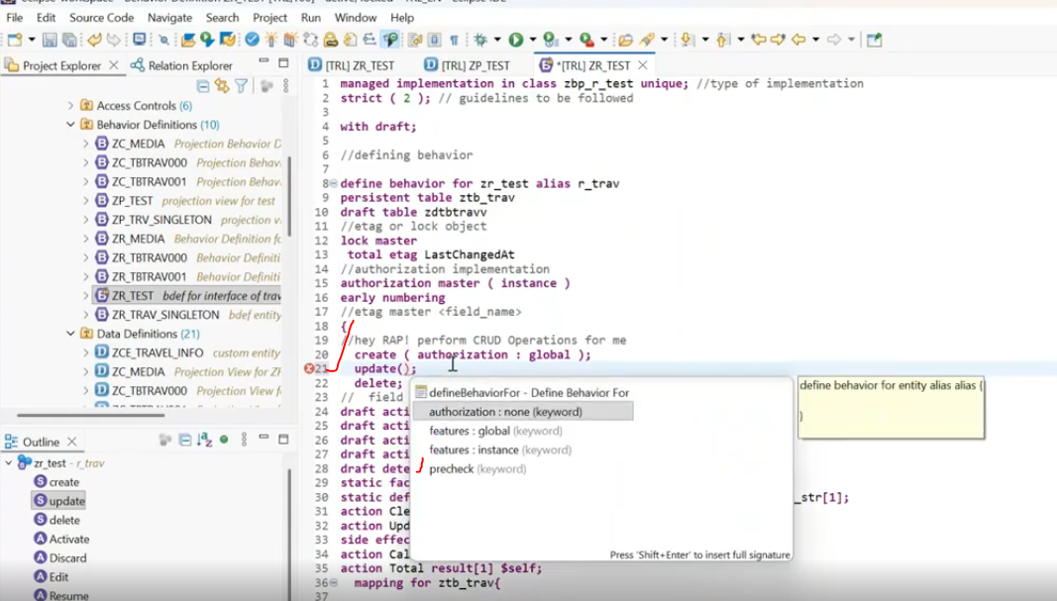
Update( precheck ) --> then it generates separate method to be implemented for the precheck . --> called as precheck_Update() method. for create--> precheck_Create( )... Delete() --> precheck_Delete().
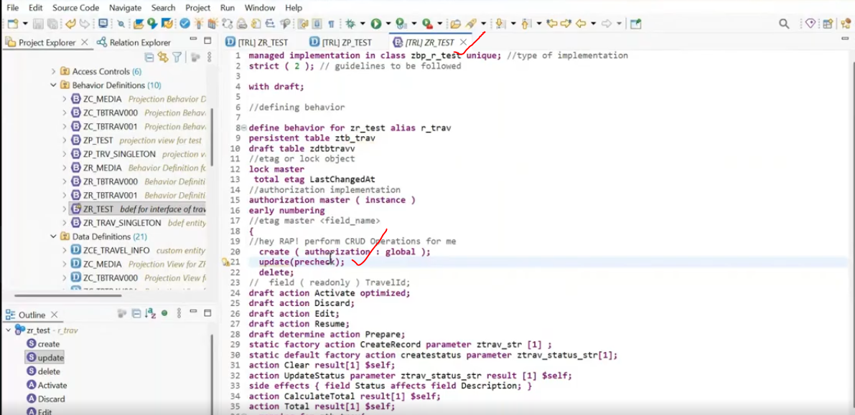
save and acctivate.
Create the precheck method. --> put the cursor on update press contrl + 1 --> it will provide the popup to add the precheck( ) method - put enter.
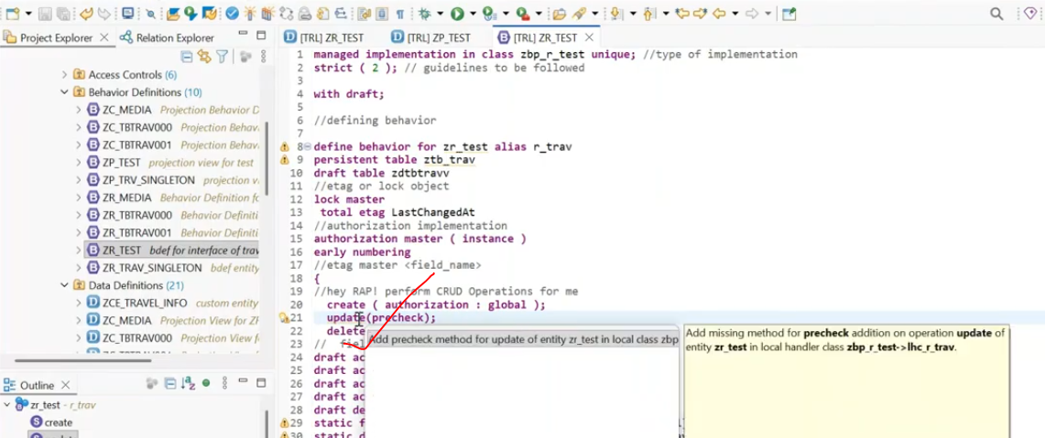
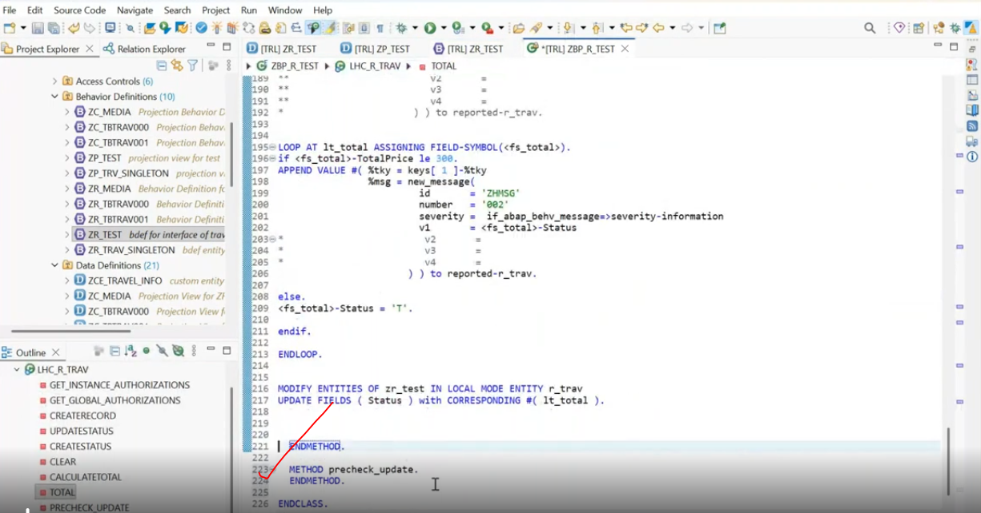
Check the parameters of the precheck_Create() methods. --> select the method name --> press F2.
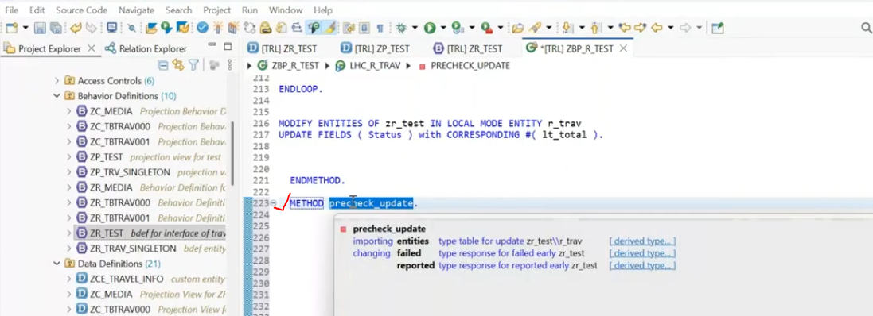
entities --> nothing but entire entities data--> which you are trying to update from the ui Level will be trigger.
entities structure.
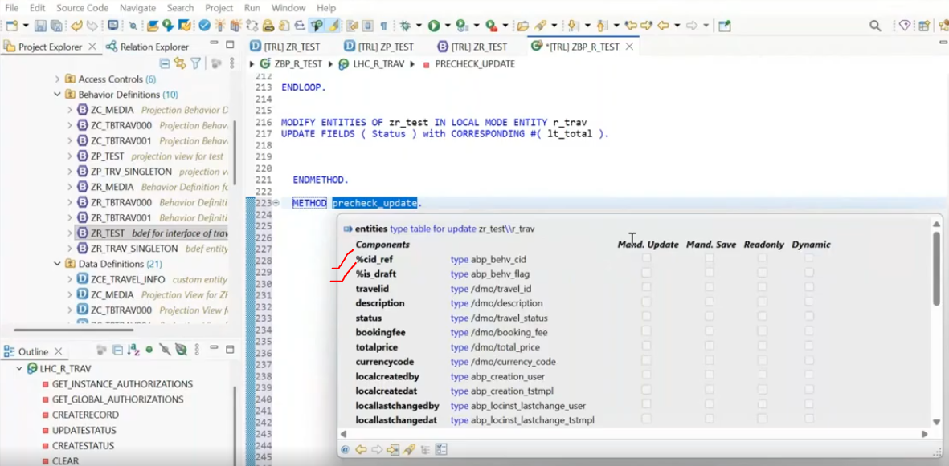
Conditions to raise the error:
1. Startdate > enddate --> raise the error.
2. if it is correct --> enddate lessthan the start date. --> i have to update the that particular record. if it is the invalid data - raise the validation, if it is valid data --> i have to update. both the things we have to do, not only the validation. if you leave it like a validation --> it doesn't perform the update operation.
3. in entities, we received the all the records of the entity. --> but we have to identifies that which record has been update and validate the data. if it is the 01, the value in control structure(%control) as we discussed in eml which tells to the update weather you wanted to commit or not, if the control value of that particular field is 01, that means we are updating the begin date, for any field... fi you get the control structure of that field -01 that is the indication user is trying to update. when you are not updating the field, you are getting the control structure value as 00. this is also we need to handle.
firstly you have to trying to get the record. --> read entities
13:00
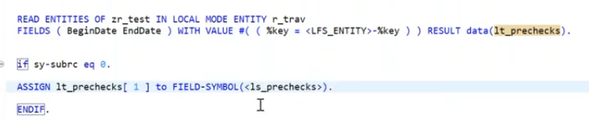
Here read the data from entities using key fields of entities and result stored lt_prechecks internal table. --> here we captured the both records( old and new record on same key feilds data)
once get the data from entities, read the internal table data and assign to new field symbol.
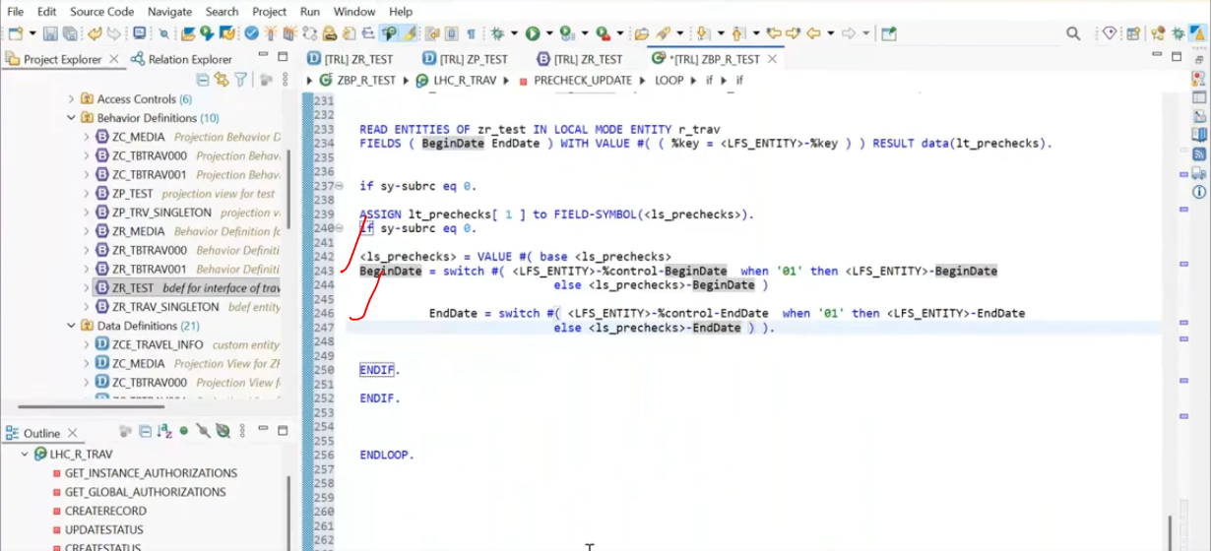
Now we have to handle the validations and send the error messages.
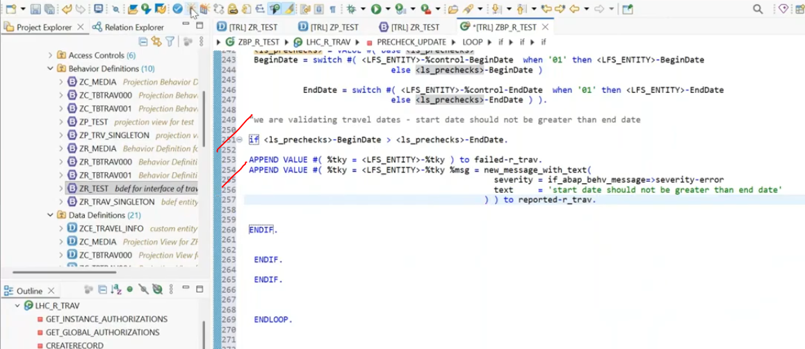
this validation only triggers, when go for update operation- trying to assign start date and end date.
22:00
for each operation for pre checks, you have to go for separate implementation.
Put break-point in this method, trigger it from front end.
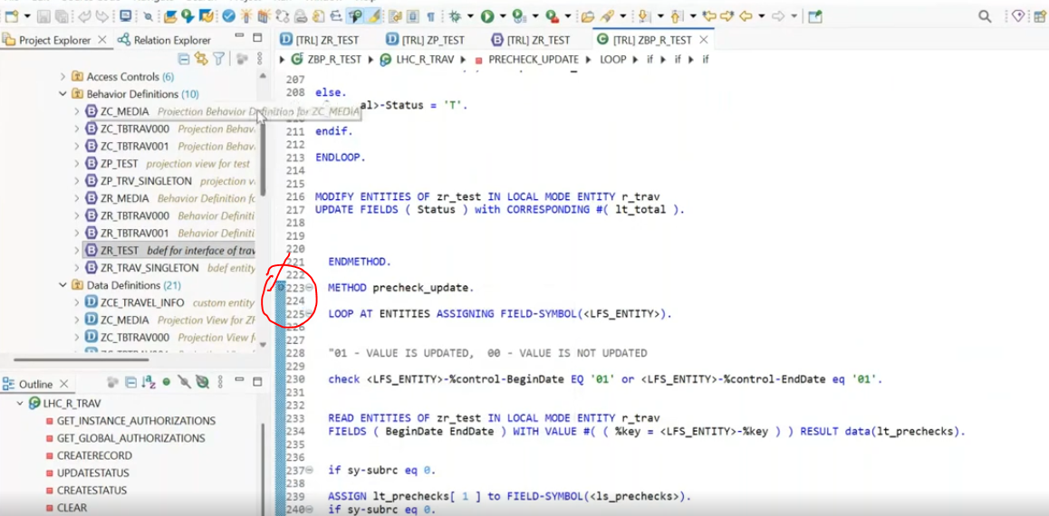

go to service bindings. select the service binding as -ZSB_TEST_V4.
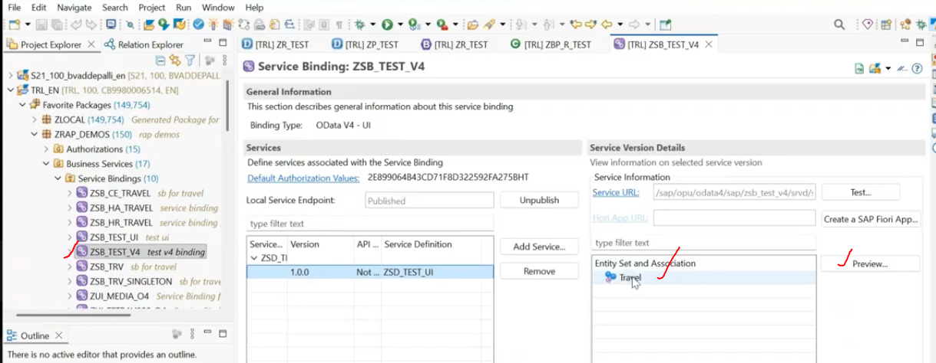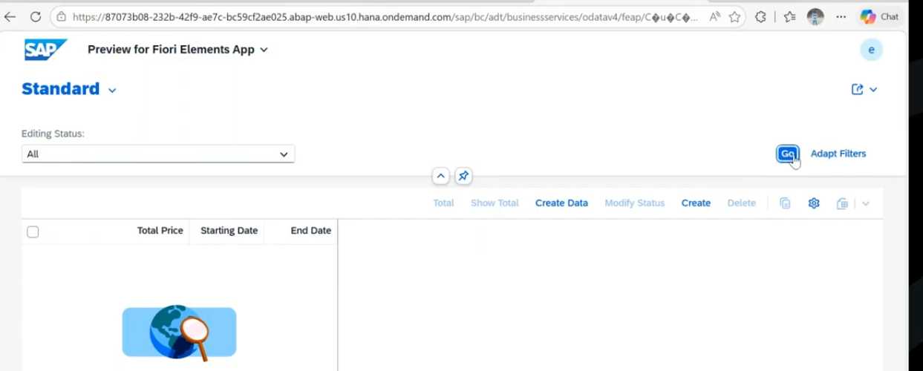
click on go --> lets try to update.
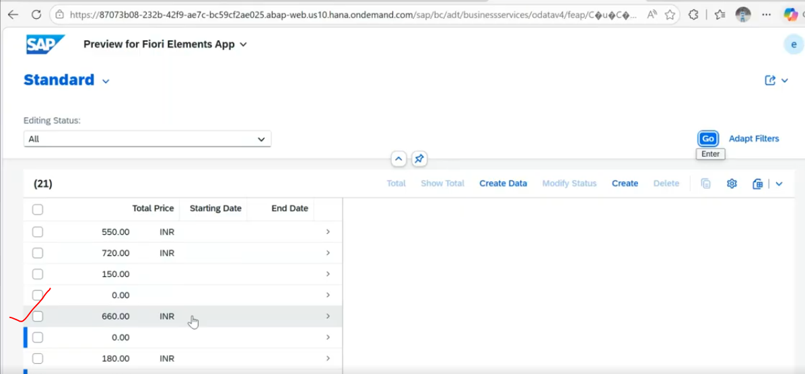
click on 660 record.. try to update.
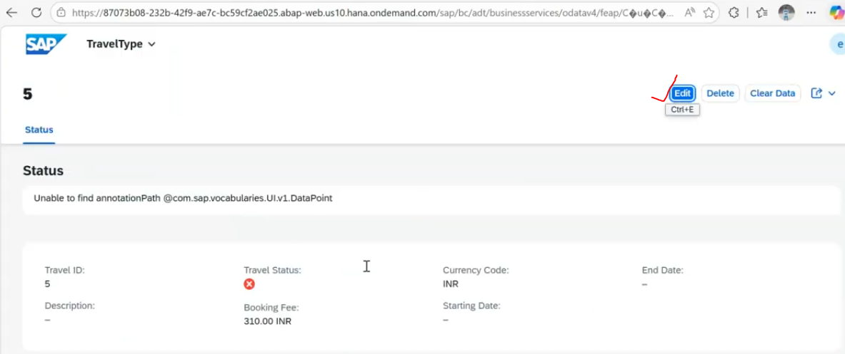
click on edit.
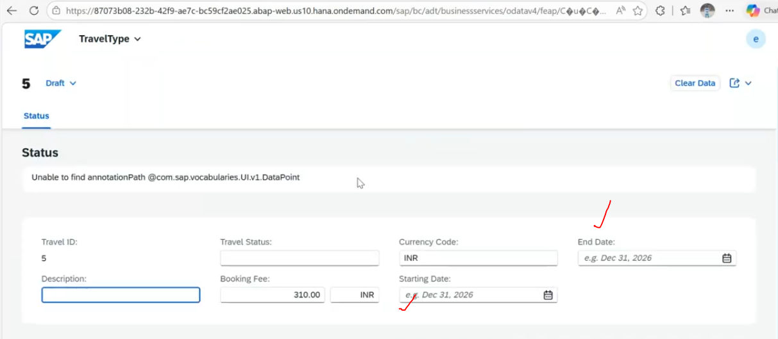
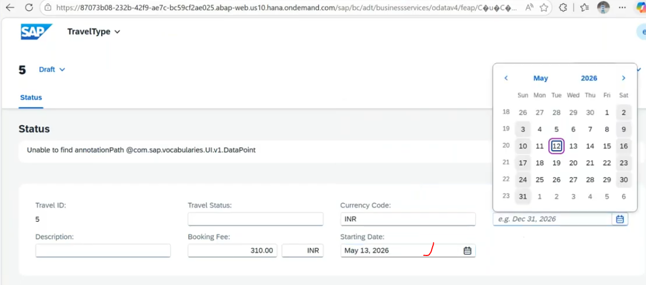
Once enter the Start date - pre-check update method will trigger. - we already put the break-point- so cursor stooped at.
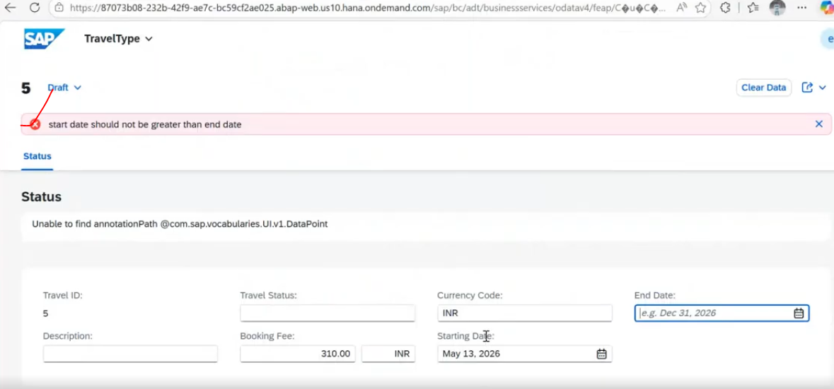
If i have choosen in enddate-
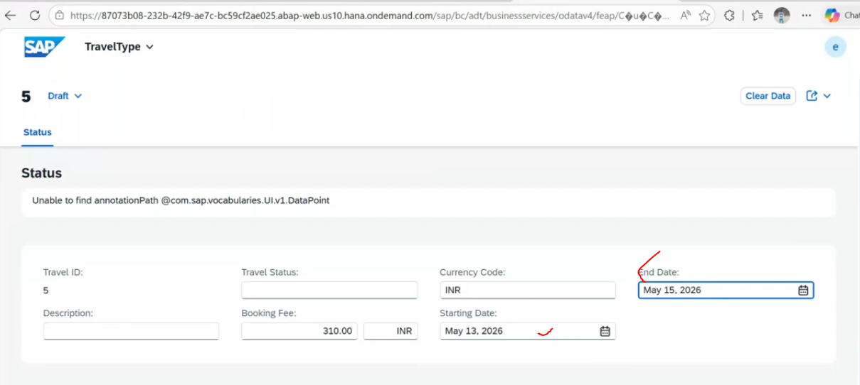
No error will come -- bcz- begin date is lessthan end date.
debugging:
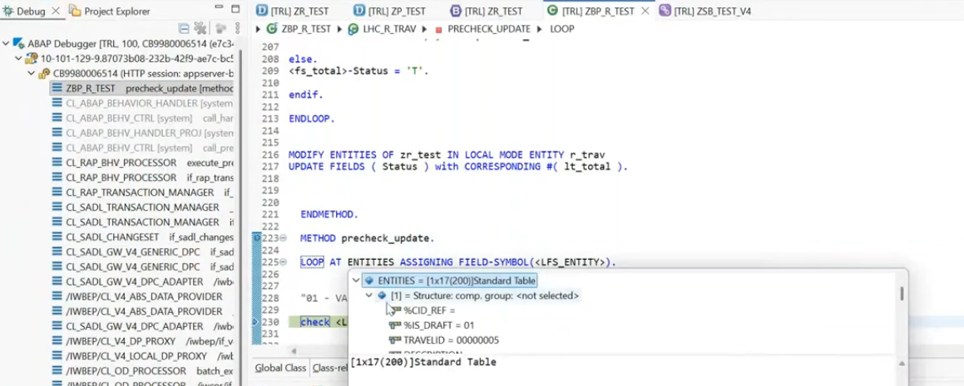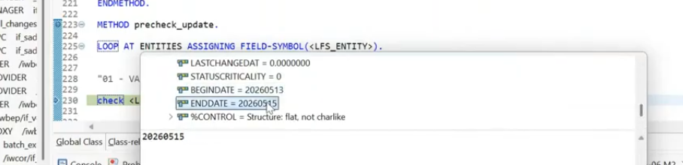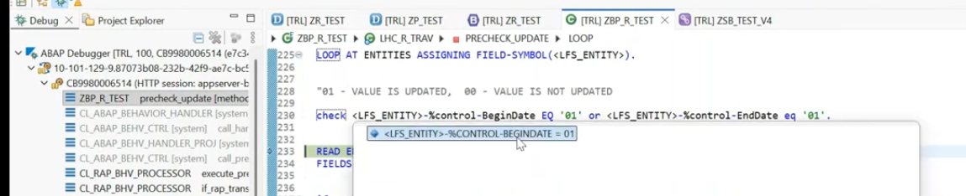
if no errors- Now click on save. -->data was saved..
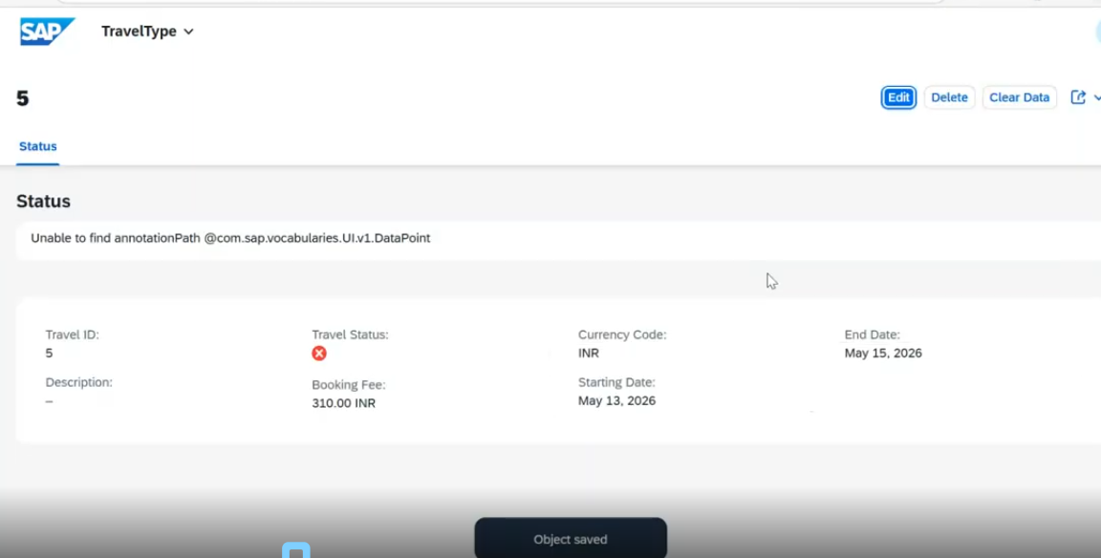
-ve case: end date - 12.05.2026 start date : 13.05.2026
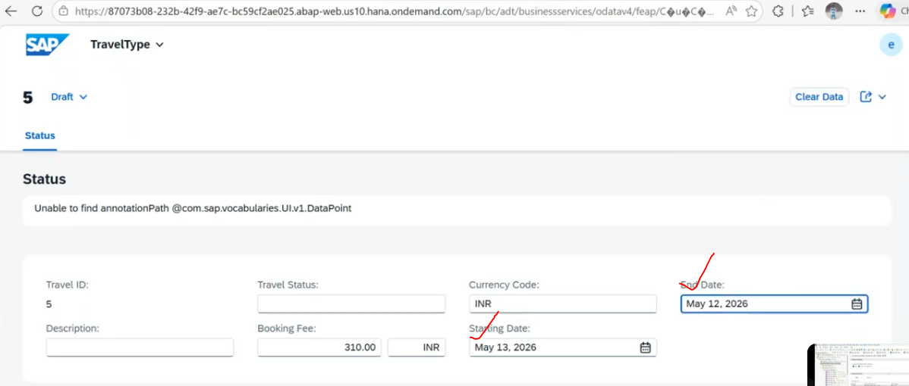
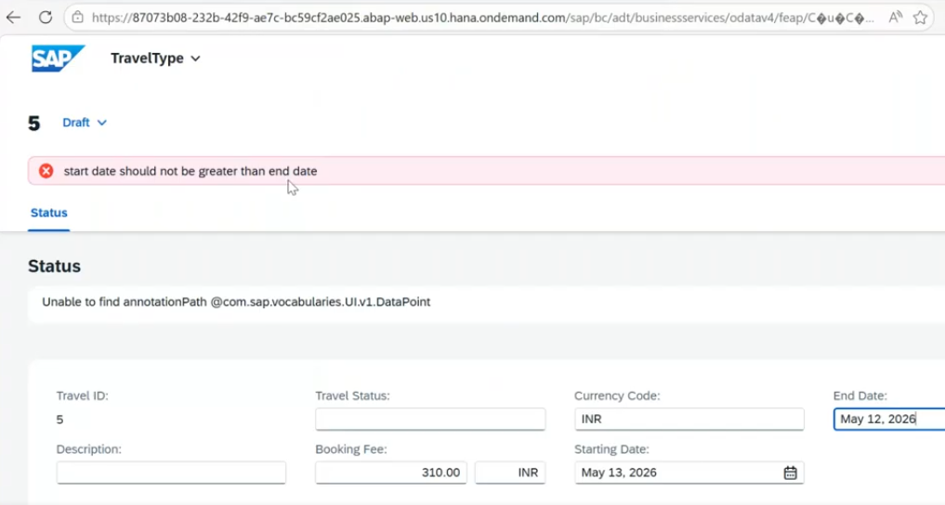

How you can bind your rap based service into the BAS?
I have one api which is rap based api, to bind it rap based api in rap- so that i can create frontend application(Explicit appl) - even we want to deploy it this will be used.
Whenever you want to bind your rap based api, so you need to have cloud foundry environment should be enabled.
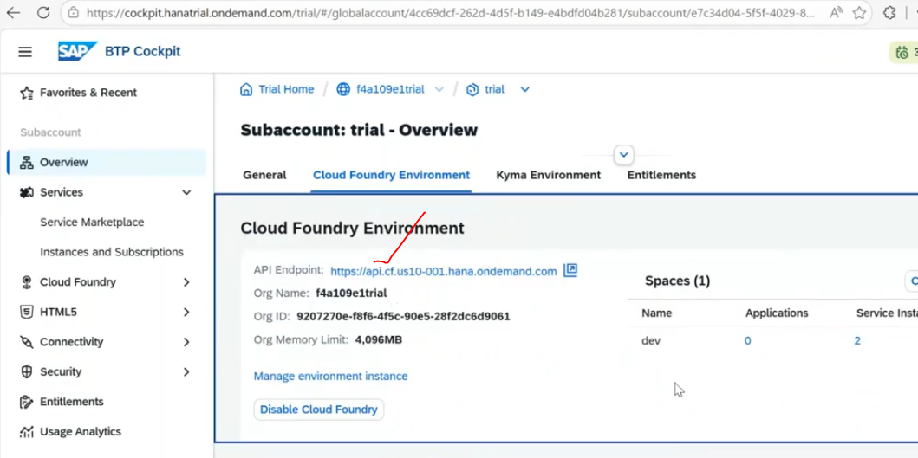
every time when you want to bind your rap based api you need to login this cloud foundry and bind it.
Step-1: GO to BAS .
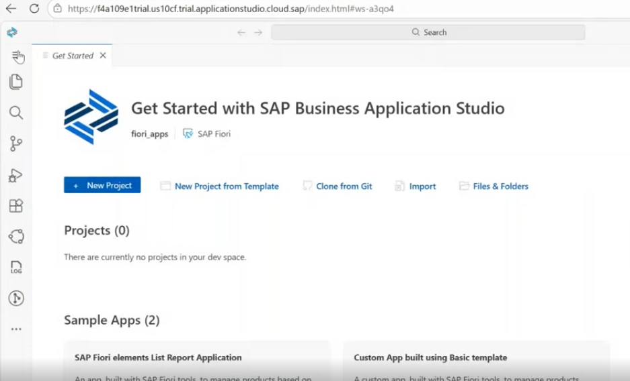
choose the new project from template.
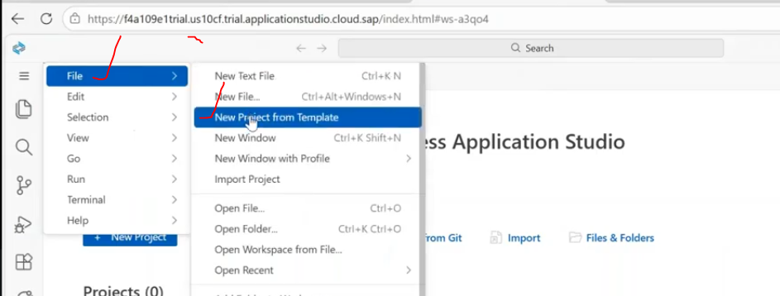
click on sap fiori generator.
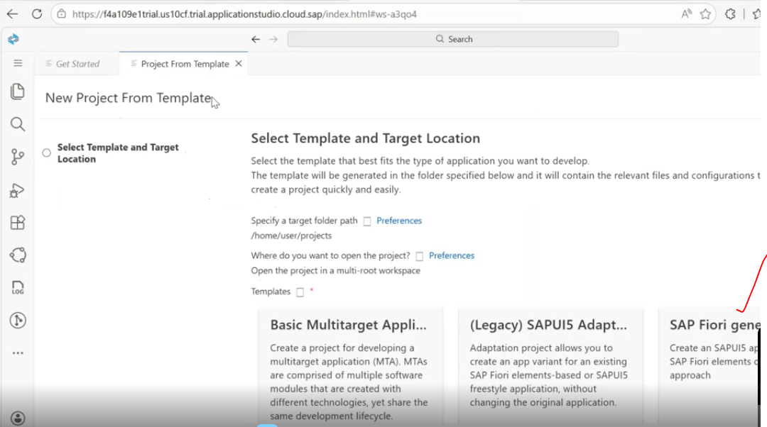
template selection:-->select the list report
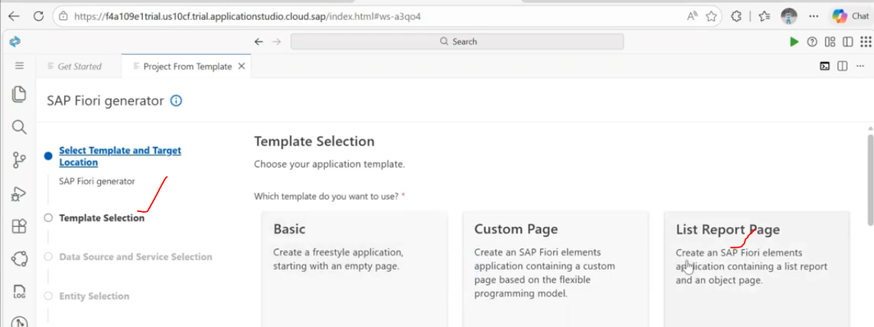
click on next ..
Data source and service selection:
now login with the cloud foundry... --> click on three (...) -->Select cloud foundry -->in applications --> click on login required.
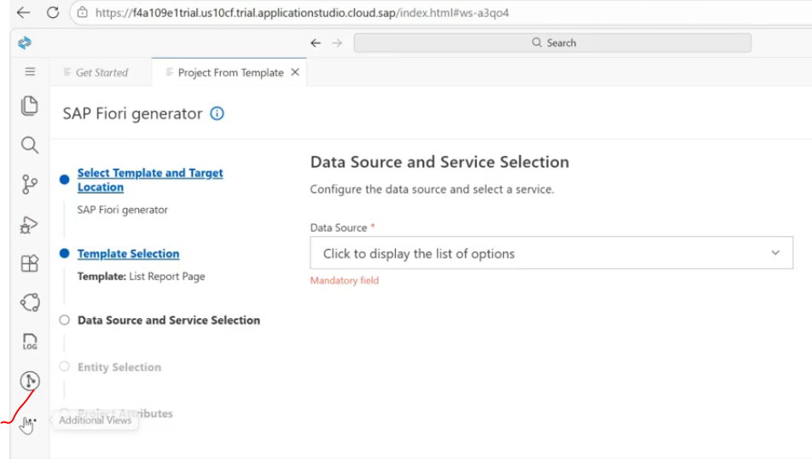
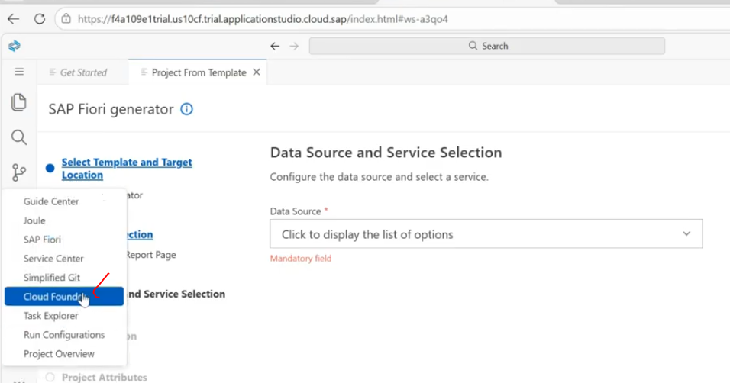
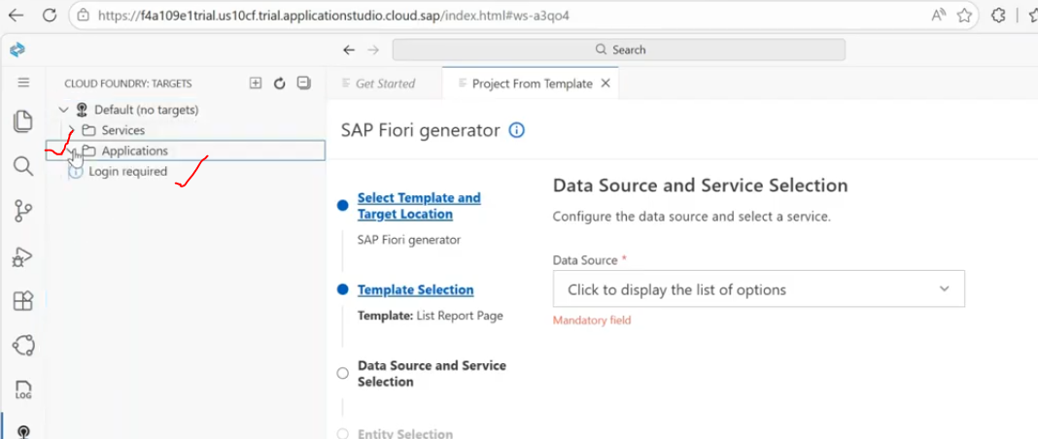
click login to cloud foundry button.
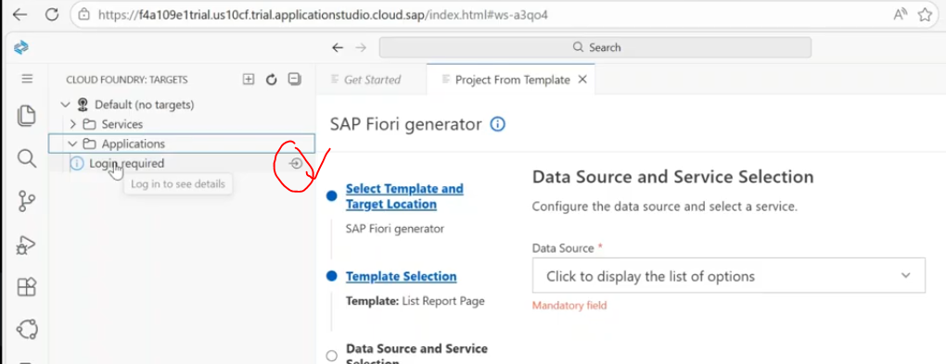
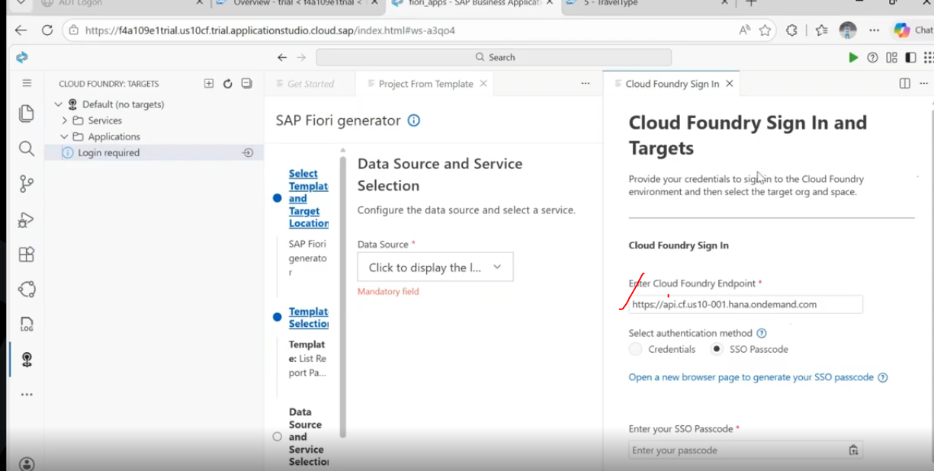
to login the cloud foundry, we have two different ways.- 1. login with btp credentials. 2. you will get the sso code.( sso-single sign on)
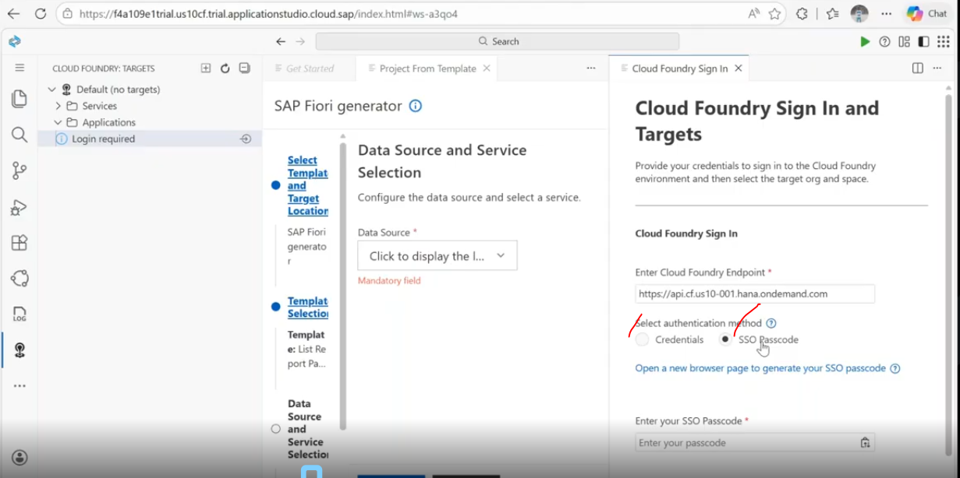
end point check in btp-
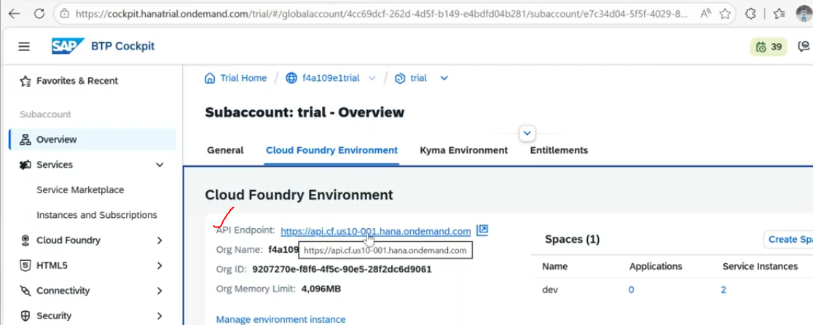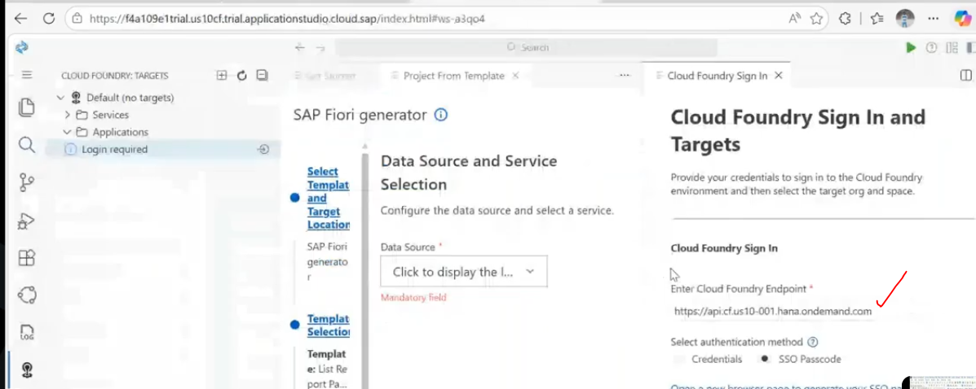
once click on "open a new browser page to generate your sso code.--> you will get the code
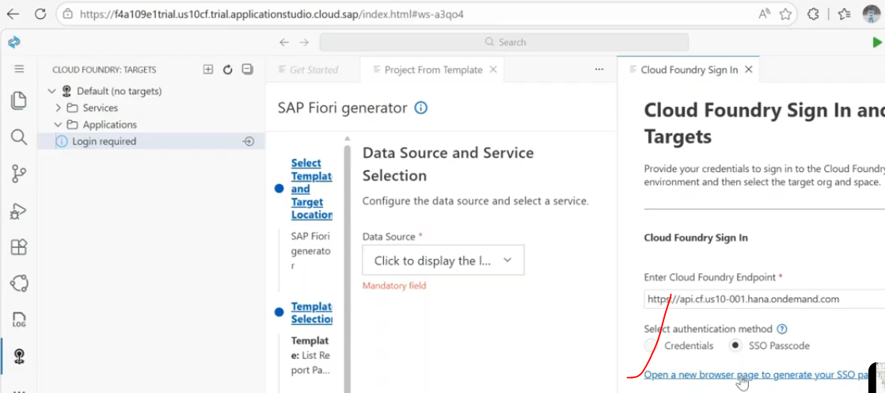
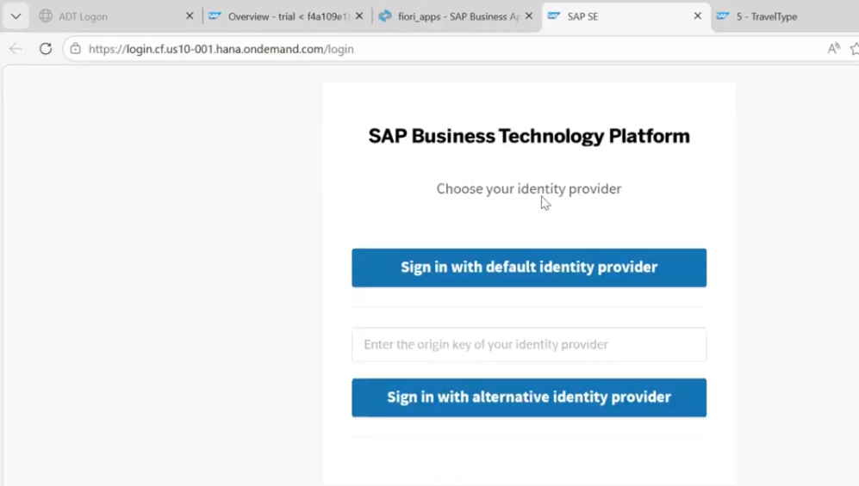
click on sign with default identity provider. --> get the temporary authencation code.
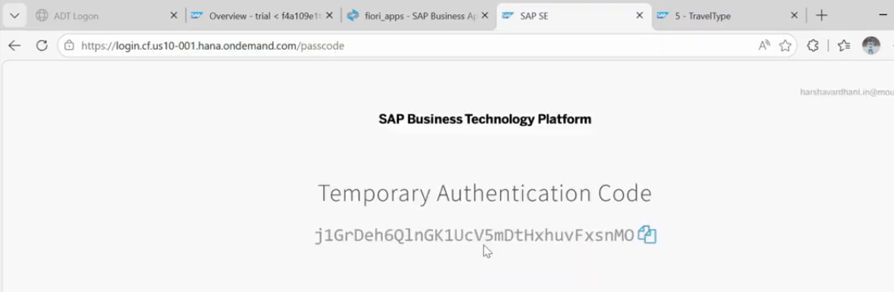
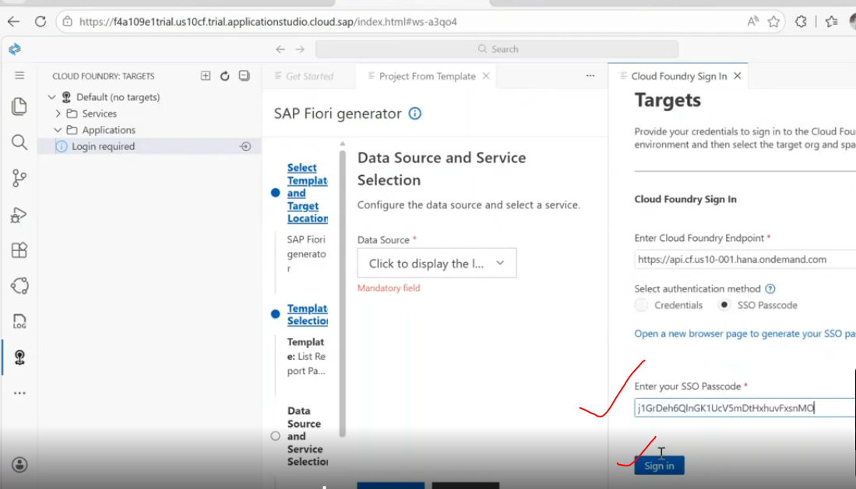
click on sign in.
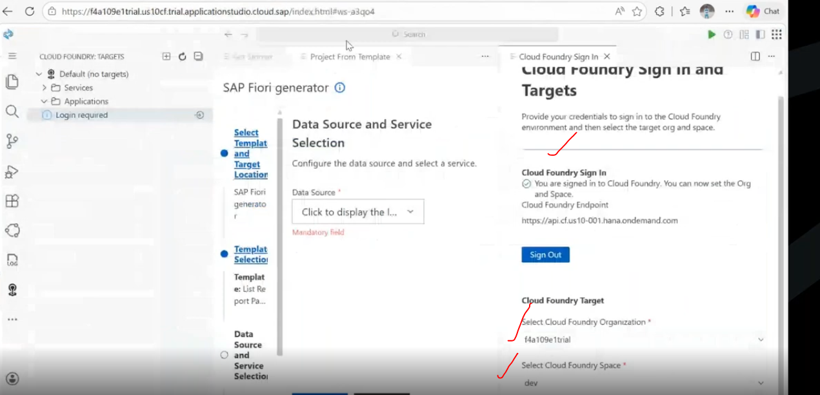
cloud foundry successfully signed in. --> once siggned in you can click on Apply.
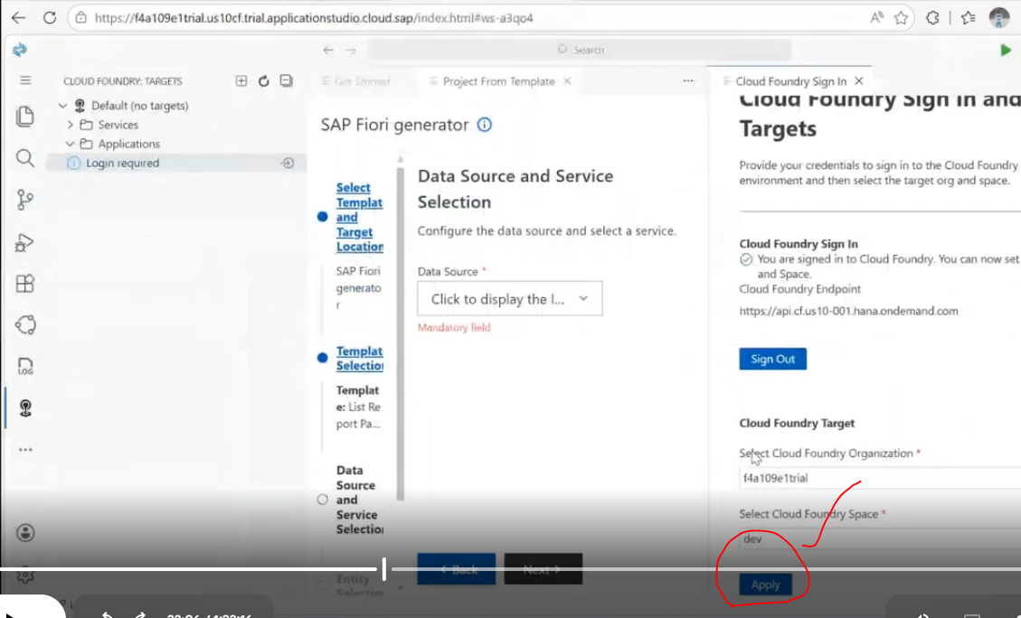
cloud foundry part completed.
Data source and service solutions:
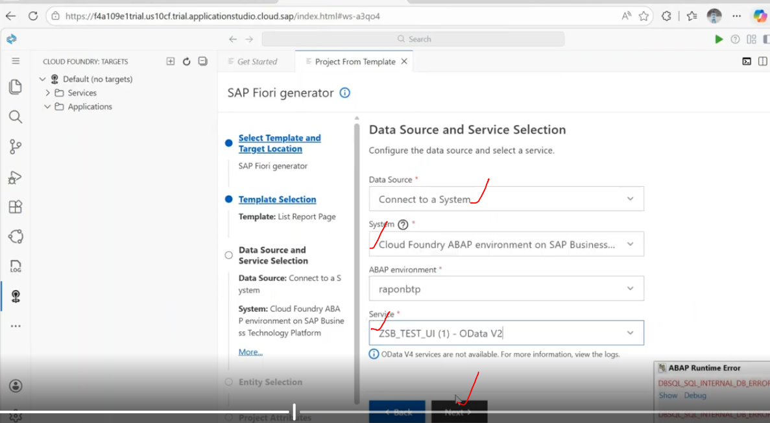
Now entity selection:
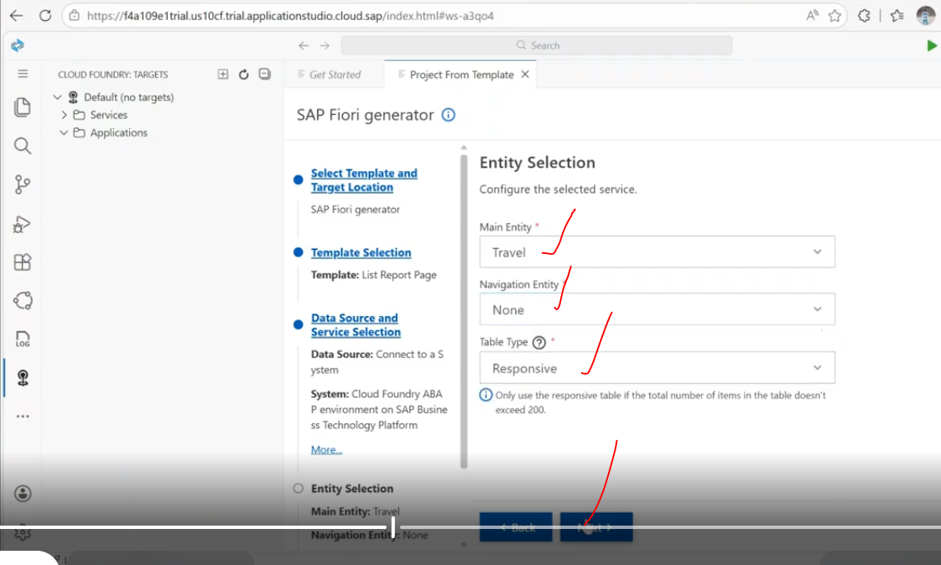
provide project attributes. -->
for on premise : deployment configuration done manually in on premise to create the tile/target mapping /sematics.. etc...
but btp - we can create at bas level only...
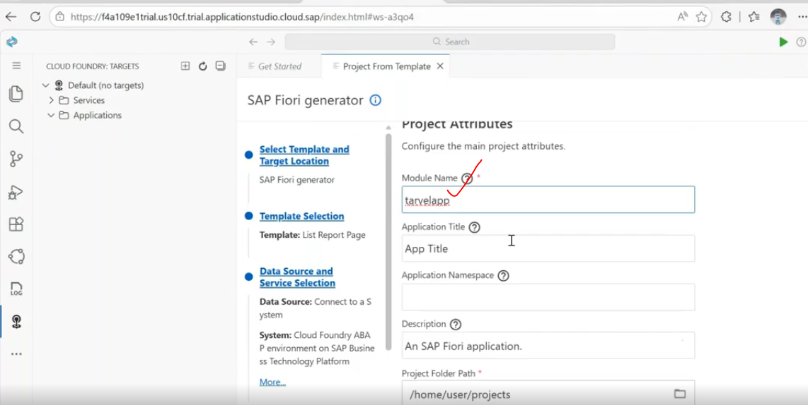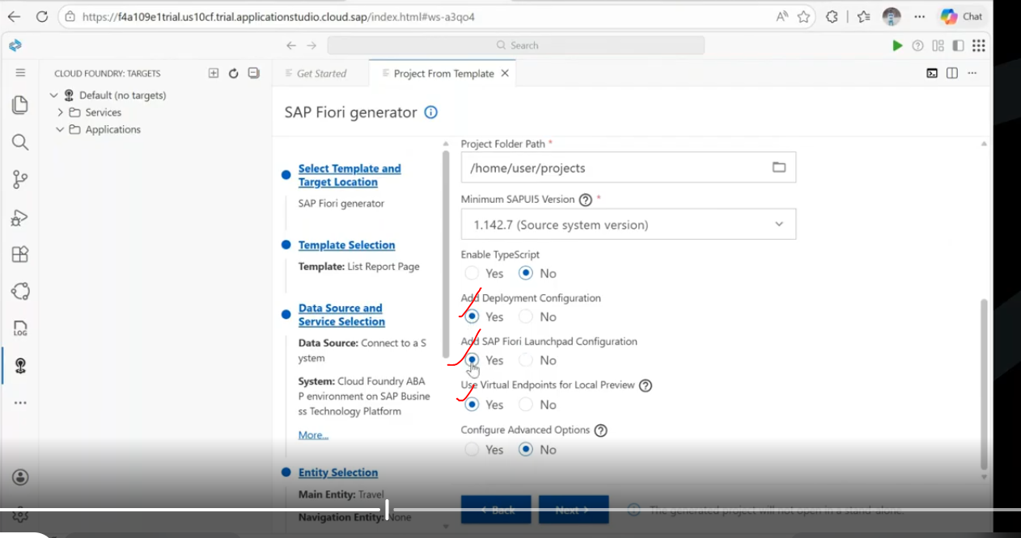
Deployment configuration steps:
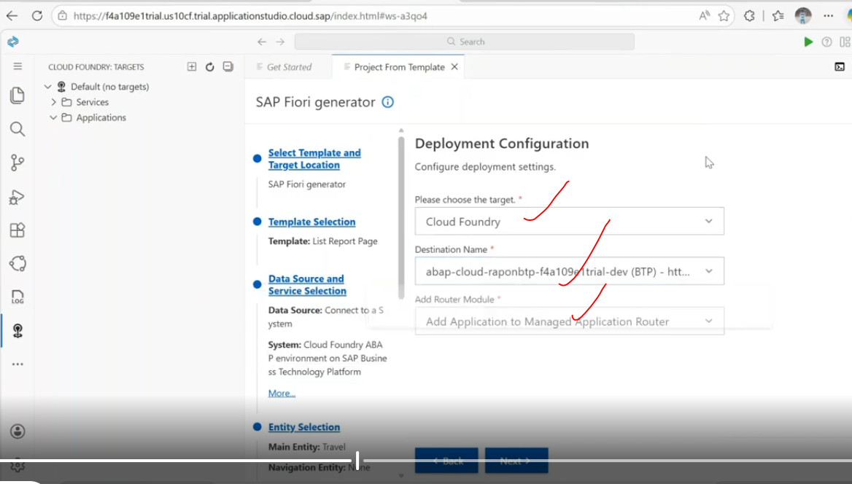
Fiori Launchpad configuration:
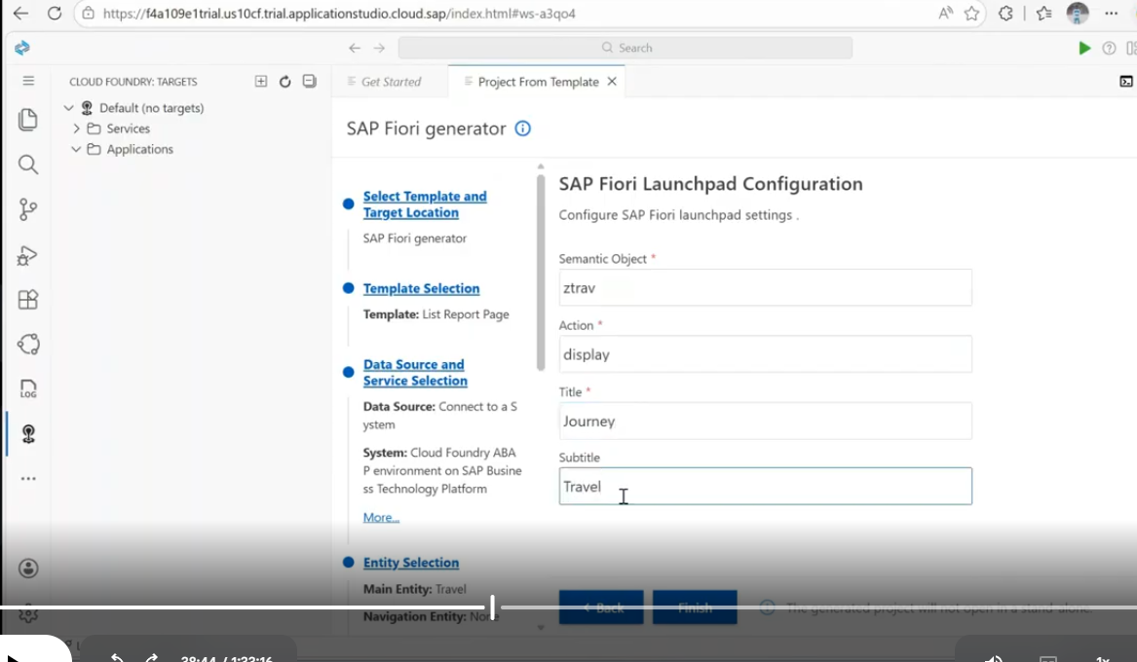
click on finish..
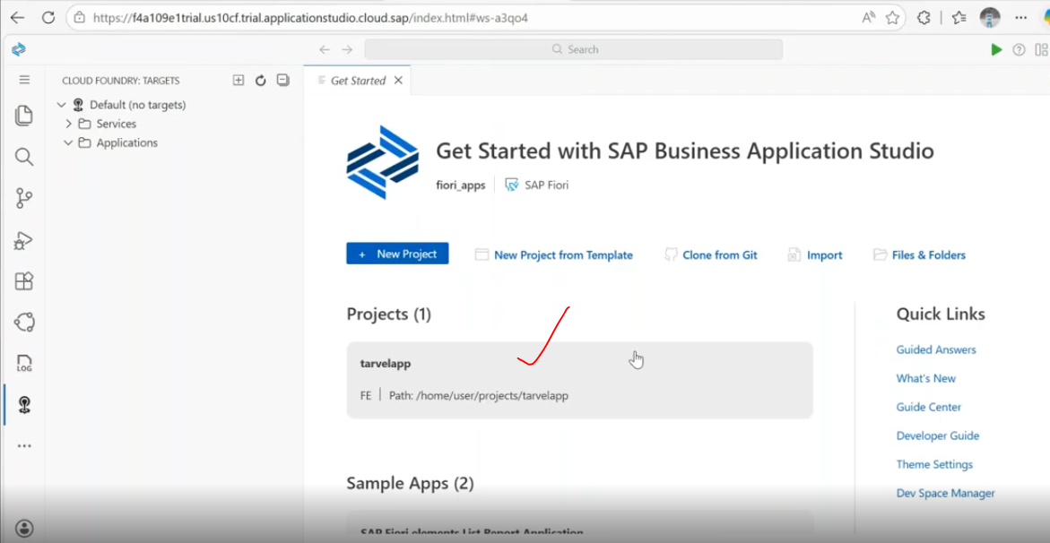
once get this path, your application will be create.
click on path
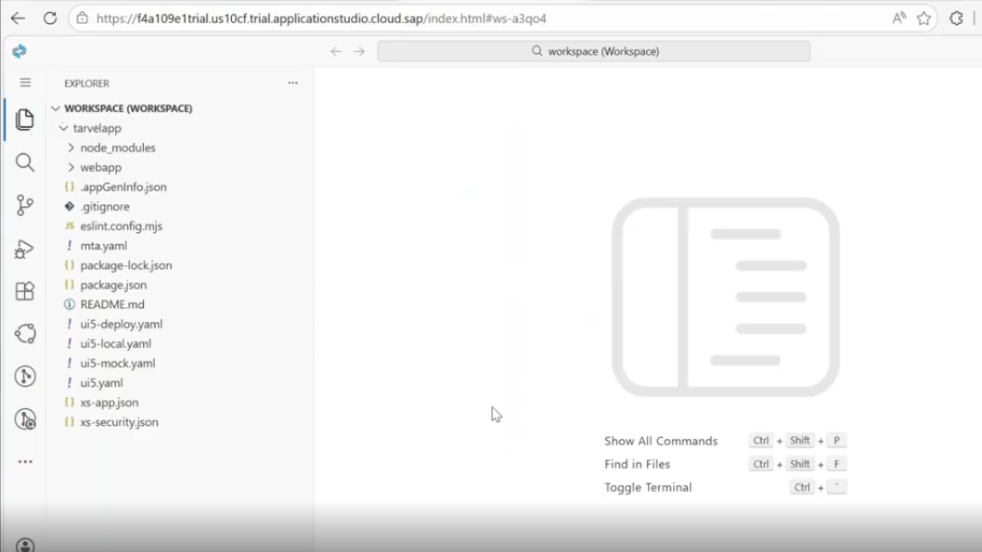
mta.yaml- deployment file, it is separate file will be generated particularly when we are going for the deployment.
now right click on mta.yaml file..
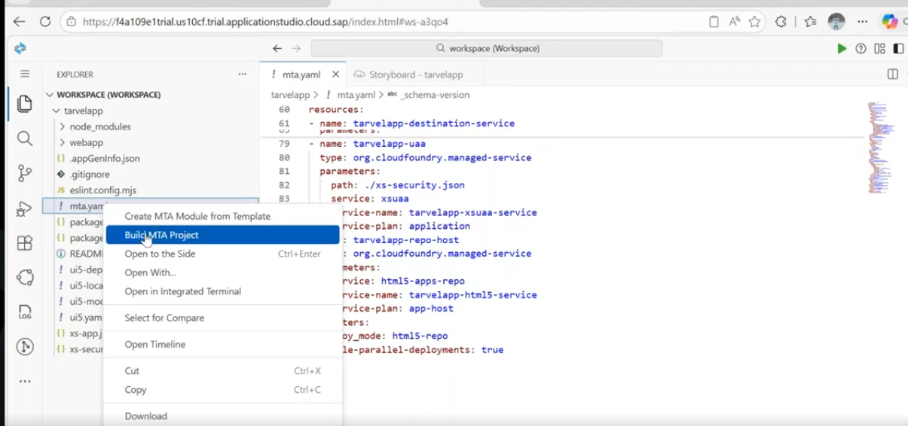
build mta project --> it will generate necessary files. --> mtar file generates.
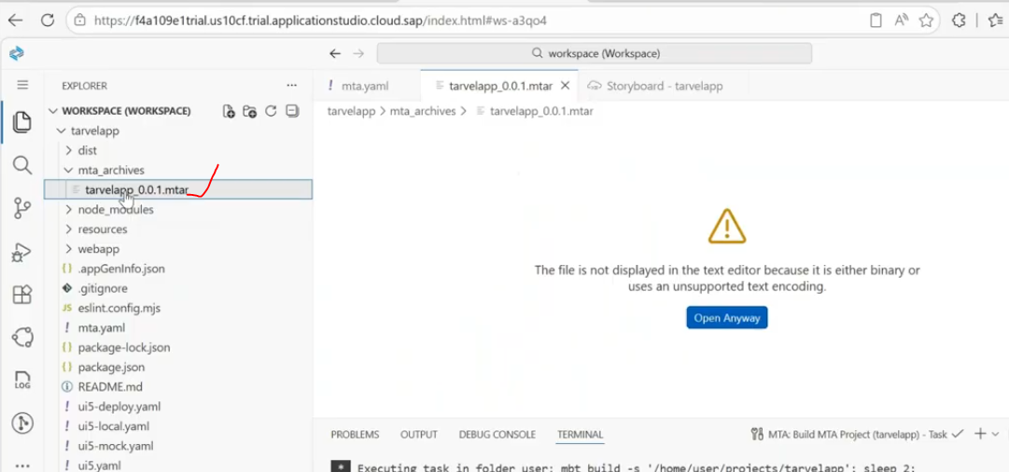
Now deploy mta archieve file..
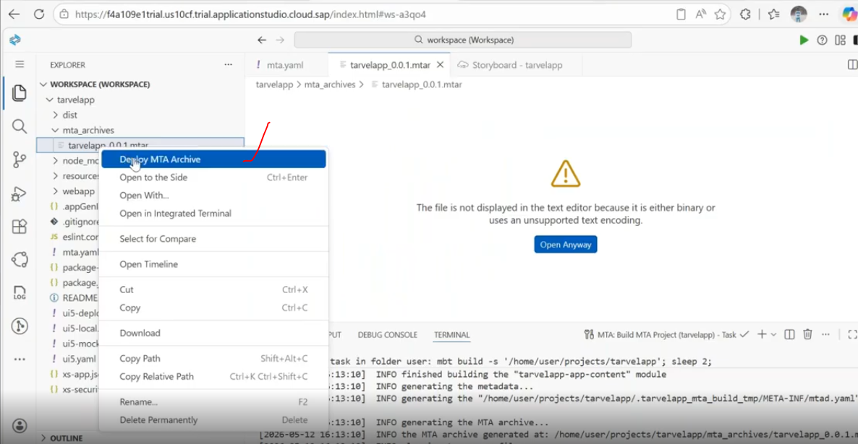
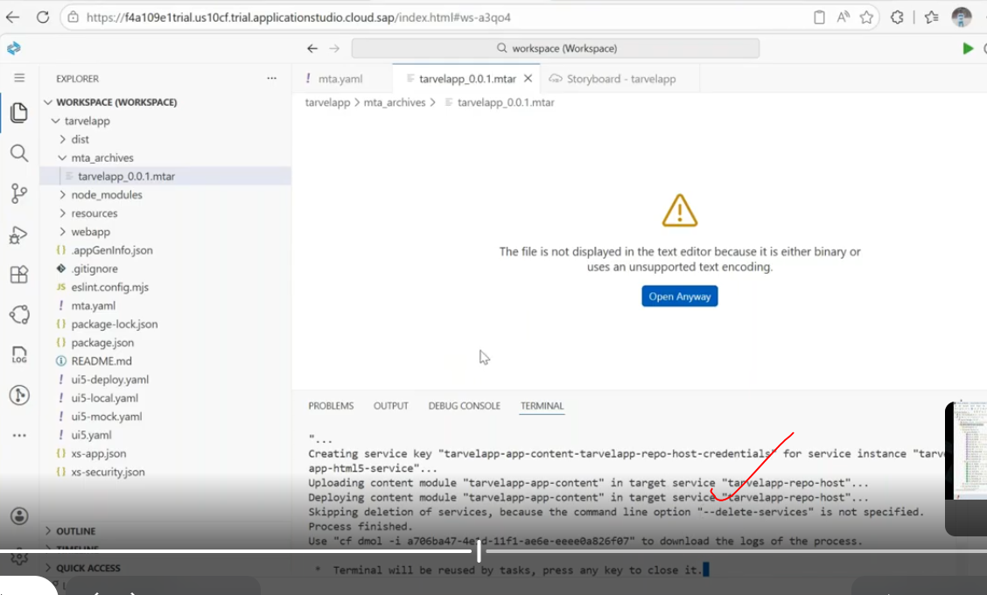
once deployment completed...
you are able to see your application in the html5 --> html5 applications. here you will able to see the application.. once deployment completed.
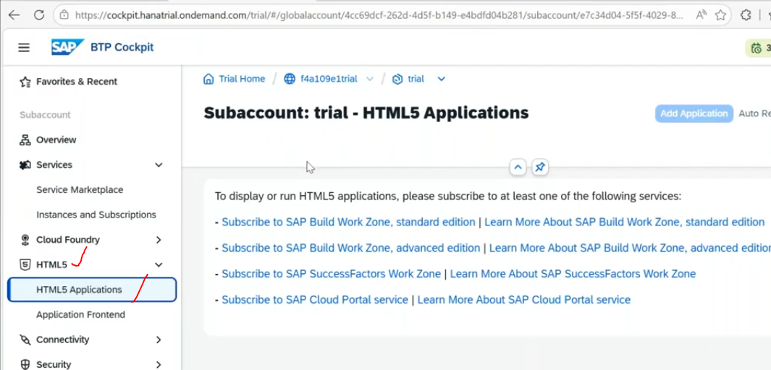
43:00
Now add the SAP build apps/work zone from booster/ Main account- not the sub account.
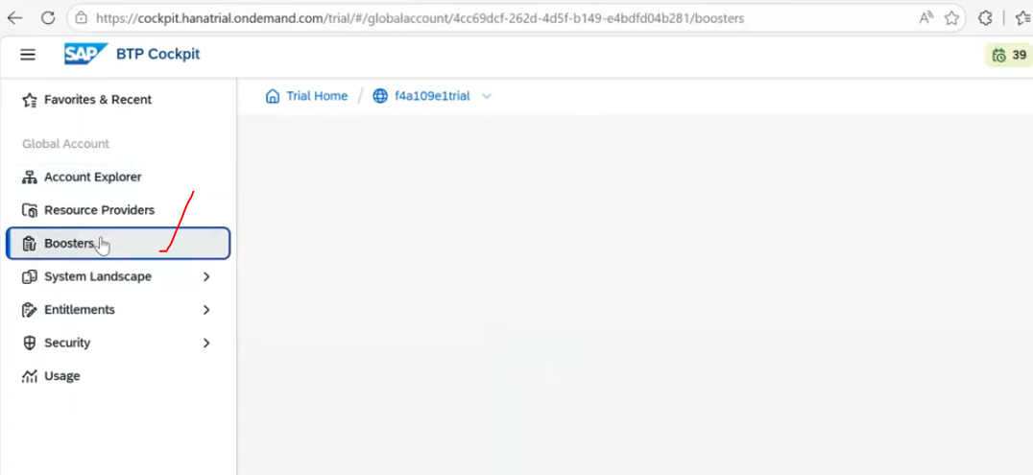
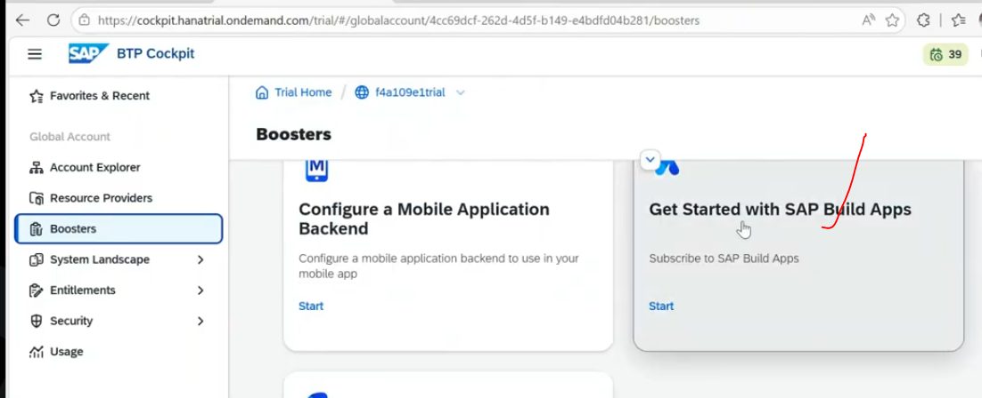
subscribe it... --> this is the way rap based application to creating front end apps in btp.
for on-premise - launchpad --> fiori launchpad
For on btp - launchpad is --> build work zone.

